Skill(s) to focus on in Activity/Drill: Solo (Hurling)
- Point the Hurley forward, with the bas flat and the toe pointing away from body towards the strong side
- Throw the sliotar onto the bas. Use a shortened grip and place weak hand on the handle towards the bas for improved control
- Move forward balancing the sliotar on the bas
- Get the head up every few steps to be aware of what’s going on around them
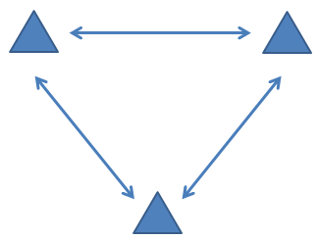

Description of Skill Activity
- 2 players at each cone
- One ball per group with a spare at each cone
- On the whistle the player at the front of one group solos towards the group opposite and drops the ball in front of the receiver who jab lifts.
- The receiving player jab lifts and moves towards the next group, dropping for jab lift when they get close enough.
- Continue in the same direction for 1 minute while jablifting and then swap and do the same drill in the other direction.
- Once the two minutes have been done do the drill again but players handpass to the next group rather than dropping for a jab lift.
Things to note and make players aware of:
- It is important to look up every 3-4 steps
- Begin slowly and build up speed as they improve
- Be sure to call the ball carrier’s name to make sure they know where to pass
- Shorten the grip and used two hands for improved control
Variations and Progressions of Drill:
- Extra cones can be added to make players change direction while moving with the ball
- Extra groups can be added and arranged to cross over each other to improve players’ awareness
- Teams can be organised to race each other transferring balls from one area to another by solo run
- A mini possession game can be played where teams have to run the ball through gates

