Skill(s) to focus on in Activity/Drill: Name the Drill here Solo (Football)
- Curl the foot so toe is pointing upwards
- Release the ball from hand on the same side as kicking foot
- Drop the ball onto the foot
- Flick the toes upwards when ball hits the foot
- Catch the ball and secure it against the body
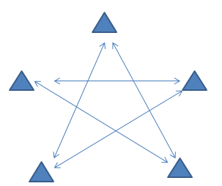

Description of Skill Activity
- 3/4 players per cone
- Start off with one ball for the exercise with spares at each cone
- The players at the cone that starts solo to the group two to their right and handpass to the person at the front of that line
- The person who receives the pass solos to the group two to their right and this pattern continues around the groups
- Once players have got used to the drill give them a time target where the ball won’t hit thr ground
- The drill can then be done in the opposite direction
Things to note and make players aware of:
- Keep the head up while soloing to be aware of other players and of where the recipient is
- Use the full four steps between each solo
- The ball should not go above stomach height when soloing
- Executing the solo correctly is more important than speed while players get used to the skill
- Calling for the ball is important to ensure the passer knows where to go
Variations and Progressions of Drill:
- The direction can be changed
- Soloing with the weak foot can be introduced
- Players have to go through a gate in the middle or zig-zag around cones on their way
- Competition can be introduced by penalising the full group for any missed solos, dropped balls, etc.

