**Hurling Training Session – Academy**

**WARMUP**

-          Get the players kitted out – Helmets on first then the Hurley’s. We’ll try and use the Academy Soft Hurls to prevent damage to the Hall floor.

-      Encourage Players to wear Shin Guards to protect the legs when playing Hurley.

-          Get All Players in the Ready Position / Demonstrate Grip and Lock with Dominant Hand First on the Hurley, do some running back and forwards across the hall.

-          Do a few Big Giant Steps (Lunges), get them to touch their trailing Leg / Knee off the Ground. Do some side steps and twists.

**HURLING**

**Area 1           *(Far End of the Hall away from the Parent Area)***

**GROUND STRIKING          (Aim / Focus – To promote correct technique | Swing in a ‘C’ Shape & Lock Hands)**

Teaching Points:

•         Feet shoulder width apart.

•         Slide the non-dominant hand into the lock position. Bend the elbows to raise the Hurley.

•         Swing the Hurley down. Strike the sliotar flat on with the bas.

•         Keep the head down. Follow through in the direction of the strike.

 Watch out for:

•         Feet too close together

•         Not standing close enough to the sliotar

•         Lifting the head to follow the sliotar

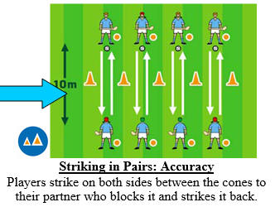

**Area 2           *(Middle area of the Hall)***

**SOLO RUNS**

Teaching Points:

•         Point the Hurley forward, with the bas flat and the toe pointing away from body on the dominant side

 Watch out for:

•         Holding the Hurley with the toe facing inwards

•         Holding the Hurley at full length

**For this exercise we can use the sand bags/balls if using the Sliotar is too difficult.**

***Setup two Lines and get the Players racing each other.***

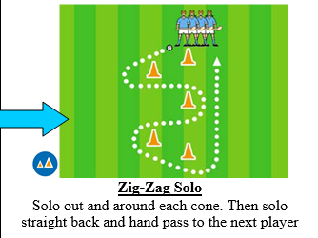

**Area 3                       *(Hall Entrance area of the Hall)***

**Jab Lift / Roll Lift**

Teaching Points:

•         Stride towards the ball

•         Adopt the lifting position

•         Slide the toe under the ball to lift it / or perform a Roll Back lift – Encourage Player to try both.

**To put a twist on it – Rather than catch the Ball in their Hand – We’ll put a Tyre out in front of them to see if they can Jab Lift the Sliotar into the ring of the Tyre.**

**Have two Lines running to speed things up and keep score of Sliotars . This will encourage Jab / Roll lifting while on the run, plus assist with Passing the Sliotar.**

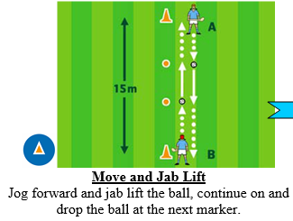

The Jab Lift is a hurling technique used to raise the sliotar from the ground into the hand. The technique is normally used when the player wants to lift a ball into the hand on the run without stopping. It is also used for a free puck.

Watch out for:

•         Holding the Hurley with the toe facing inwards

•         Holding the Hurley at too great and angle.

**Area 4           (Hurling Wall)**

Weather permitting – rotate the Groups out to the Hurling Wall for Match and Keeping the Sliotar off your side of the Pitch.