**Hurling Training Session – Academy**

**SETUP**

Mark out 4/5 pitches with goal posts (which we can use for the football matches later) and assign a station at each pitch.

**WARM UP**

Quick game of flush the toilet and then get the helmets on and hand out hurleys to each kid.

**HURLING**

***Station 1: Obstacle course***

Using tyres, steps, jumps and so on. Kids should hold the hurley and sliotar when doing the obstacle course.

***Station 2: Ground Strike***

Teaching Points:

•         Feet shoulder width apart.

•         Slide the non-dominant hand into the lock position. Bend the elbows to raise the Hurley.

•         Swing the Hurley down. Strike the sliotar flat on with the bas.

•         Keep the head down. Follow through in the direction of the strike.

Watch out for:

•         Feet too close together

•         Not standing close enough to the sliotar

•         Lifting the head to follow the sliotar

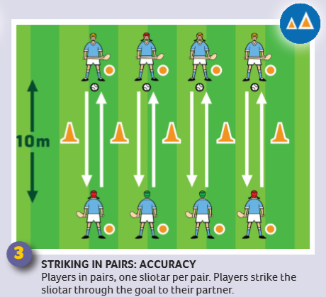

***Station 3: Dribbling***

Teaching Points:

•         Bend the hips and knees, place the heel of the Hurley on the ground.

•         Non-dominant hand, placed down the handle of the Hurley.

•         Use alternate sides of the bas on every second stroke

•         Progress to one hand.

Watch out for:

•         Locking the Hands

•         The bas of the Hurley striking over the top of  the sliotar

•         Pushing the sliotar too far in front

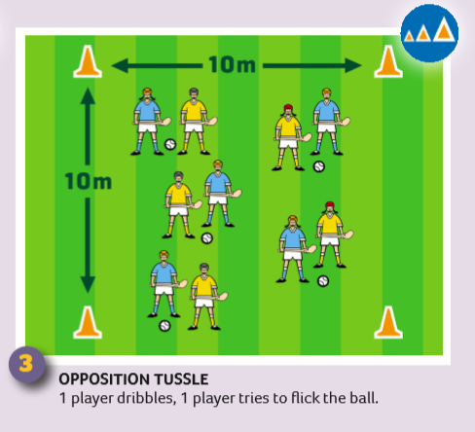

***Pitch 4: Hand Pass***

Teaching Points:

•         Swing back the non-dominant arm; strike the sliotar in the direction of the receiver. Point of impact is where fingers meet palm of the hand.

Watch out for:

•         Tossing the sliotar too high

•         Swinging the non-dominant hand back too far

•         Striking the sliotar with the palm of the hand

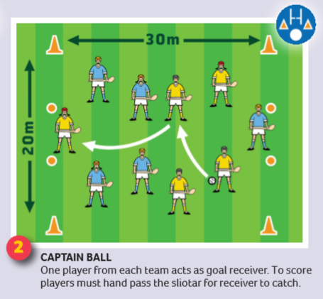

***Pitch 5: Solo Run***

Teaching Points:

•         Point the Hurley forward, with the bas flat and the toe pointing away from body on the dominant side

Watch out for:

•         Holding the Hurley with the toe facing inwards

•         Holding the Hurley at full length

