**FOOTBALL SESSION USING THE HALL AND HURLING WALL**

**WARMUP**

1.       Check for gumshields

2.      Traffic lights – get the players moving, green is go, red is stop and orange for fun (hop on one leg, lunges, crawling).

**Area 1           *(Far End of the Hall away from the Parent Area)***

**HAND PASS / KICK PASS (MIX)**

-          Start off with one to one Hand Passing

-          Then introduce a Kick Pass every Second Go

-          **Then Mix the Group around – 4 Corners, Player in each corner.**

1st Player runs to the middle to Receive a Ball from each corner which encourages rotation and pressure passing, when

the 1st Player has received and passed back 3 x balls, he’s back to his Corner and then the 2nd Players turn in the middle. 3rd and 4th Players turns.

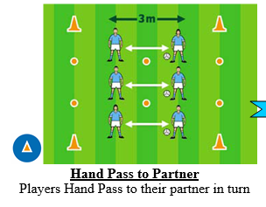           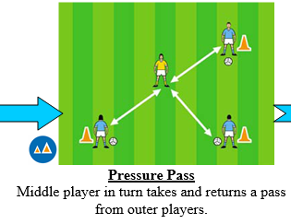

**Area 2           *(Middle area of the Hall)***

**PUNT KICK INTO TYRES**

*Aim of this drill is to teach the kids how to target effectively with a kick*

Teaching Points:

•         Release ball into hand at kicking side, kick ball with instep, keep toes pointed

Watch out for:

•         Dropping the ball with the opposite hand to kicking foot

**Station Setup:**

Two lines facing the wall, about 5-7m metres from the wall. Each line will try to punt kick the ball into a 3 x tyres lying against the wall.

**Area 3           *(Hall Entrance area of the Hall)***

**OBSTACLE COURSE**

Layout two identical course lines which include hurdles, ladders, ball handling, bouncing, side stepping cones, fist pass back to the next player in line.

Have two lines and get the players team racing, but stop when necessary to make corrections to players handling skills or “Short Cuts” taken… ☺

**Area 4           *(Hurling Wall)        (ROTATE THE GROUPS TO GIVE EACH GROUP A TURN OUTSIDE)***

**OVER THE RIVER**

Aim of the drill is to encourage the kids to watch the ball, move and catch high balls

Teaching Points:

•         Catcher - Move to receive the ball at the best position, extend arms, cushion the ball

Watch out for:

•         Catcher - Closing the eyes, leaning back rather than stepping back.

Encourage high kicks to clear the ball from your side.

If a player on the other team catches the ball then they get a bonus point which will be deducted from their ball count and the end of the game.