Skill(s) to focus on in Activity/Drill: Overhead Catching
- Keeping your eye on the ball
- ‘W’ hands – hands open
- Bring the ball into the chest
- Keep moving and anticipating
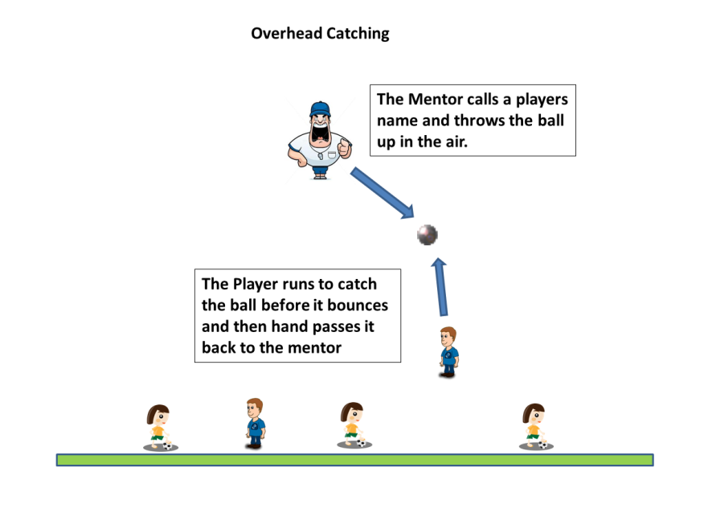

Description of Skill Activity
- Have 1 ball per 4/5 players
- Line up the players along the end line or a line of cones
- The mentor stands approx. 5m across from the players.
- The mentor calls the name of a player and throws up the ball.
- The player tries to catch the ball overhead or before it bounces.
- Player then hand passes the ball back to the mentor.
Things to note and make players aware of:
- Reach for the ball
- Spring from the ground to catch the ball
- Moving forward to catch the ball.
- Catch and tuck into the players chest
- Accurate and proper hand pass back to the Mentor while on the move.
Variations and Progressions of Drill:
- Adjust the height of the ball thrown
- Adjust the angle of the ball thrown
- Have two player competing for the ball
- Have a defender and an attacker competing.

