Skill(s) to focus on in Activity/Drill: Hand passing when moving - Accurately and at pace
- Pass should be directed at receiver’s chest.
- Pass to be struck off fingers not palms of hand.
- The hand passing should be done at pace.
- Encourage longer passes for more able players.
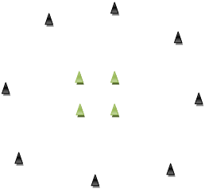
Description of Skill Activity
- 5 balls per group of ten players. 5 players inside the middle square (marked by 4 cones), each with a sliotar. The 5 players spread around the outer circle (Marked with cones) with no sliotar.
- On the whistle the players on the inside (Passer) run towards any player on the outside (Receiver) and hand passes to them.
- They receive the sliotar back, travel back through the middle square and on to another player on the outside.
- Continue for 1 minute and then swap the inside and outside players. Each player gets 3 turns as a passer.
Things to note and make players aware of:
- They should be running with head up or at least glancing up and then back at sliotar on hurl.
- Encourage players to focus on accurate fast delivery of the ball to the receiver’s chest. No “loopy” high balls or poor low passes.
- Change direction – don’t go in any order to people on the outside, randomise it based on who is available and calling – step off right, step off left, side step people in the middle
- After passing the sliotar the player should not stand still waiting for the ball to be returned – he/she should move off at an angle to receive the return pass
- Distance of the outside cones to the middle cones is dependent on the age group and how hard you want them working
- Communication is vital – call names so not everyone is running to the same person on the outside
Variations and Progressions of Drill:
- Instead of receiving a regular hand pass from the outside person the player running could:
  - Run around the back of the outside player who can:
    - Throw the ball in a random direction in front so the running player has to adjust and jab lift on the run
    - Throw the ball up in the air so the running player has to jump and catch high ball
  - Do 5 sit-ups/press-ups/star jumps then jab lift and move on
- Increase of decrease the length of the pass. Ask players to pass directly off their hurleys or swop hands and pass with their weaker hand.

