Skill(s) to focus on in Activity/Drill: Improvised Evade and Pass Game
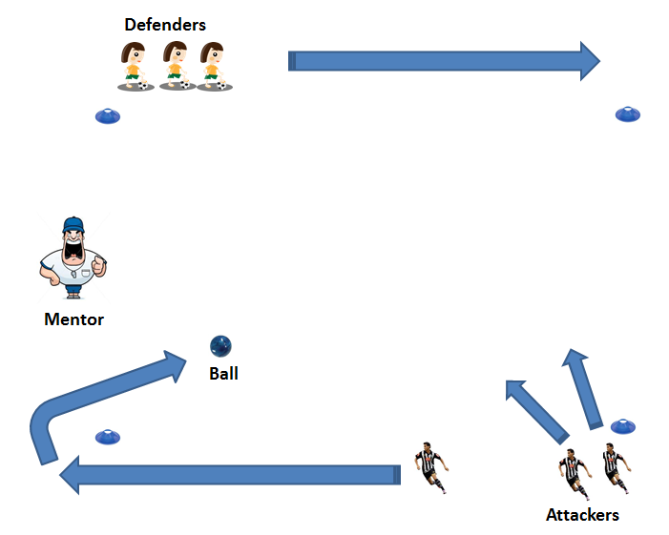

Description of Skill Activity
- 3 Attackers V 3Defenders
- 1st Attacker runs to ball
- 2nd and 3rd Attackers run into space and look to receive the ball
- Attackers need to evade defenders and pass to a fellow attacker.
- If they complete 3 passes then the ball is returned to the mento.
- Defenders try to disrupt and try to win the ball. The they become attackers.
Things to note and make players aware of:
- Receiving attackers finding space to receive the ball.
- Constant movement of players
Variations and Progressions of Drill:
- 1 on 1
- 2 on 2
- 3 on 3 (intensity increases with numbers)
- Drill can be used for hurling or football
- Change to foot pass only or short strike pass from hurley

