Skill(s) to focus on in Activity/Drill: Attacking and Defending in pairs at pace.
(The drill was outlined by Shane Cullinan U15 Hurler)
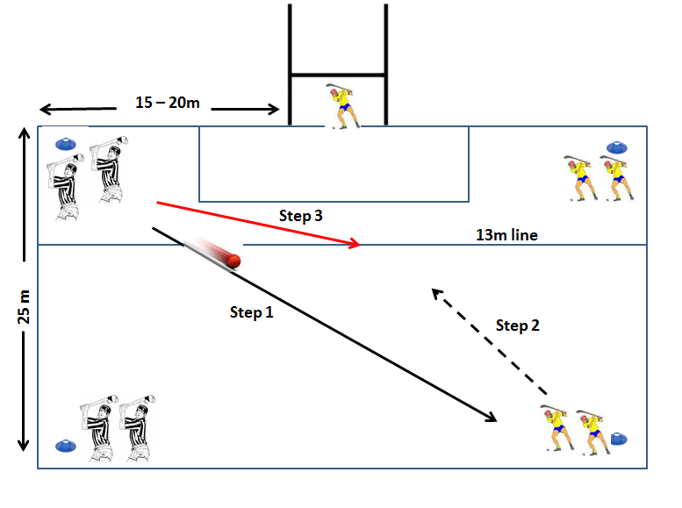
Description of Skill Activity
- 4 cones (indicated in blue above)
- Players paired off in twos at each cone
- One Goalkeeper. Goals only and to only scored inside the 13 metre line.
- (Step 1) The first pair on the end line strike the ball diagonally across to the other pair and then follow it.
- (Step 2) The pair who received the ball, then have to work in towards goal, (Step 3) while the other pair try to defend.
- The object of the drill is for the attackers to score a goal or the defenders to stop the attack.
- If a goal is scored, the defenders win it back or the ball goes out of play, then the play is over and the pairs swap over.
- The other pair on the end line then strikes the ball diagonally to the opposite side and the drill continues.
Things to note and make players aware of:
- Good support play.
- Meeting the ball at full pace.
- Shortening the grip to get a strike on goal.
Variations and Progressions of Drill:
- Vary the distances
- Have 3 attackers v 2 defenders or vice versa

