**Hurling Training Session – Academy**

**WARM UP**

Helmets on and hurley in hand. Start with the ready position, move to the lock and check the grip ( dominant hand always at the top of the hurley).As per last week, start off with a few shuttle runs and get the players running. Throw in a few Bear Crawls, Leap Frogs, side step and backwards running all with the hurley in hand.

**Pitch 1.**

**Stopping a ground ball**

Split into pairs- players roll the ball to their partner to stop the ball and return to partner

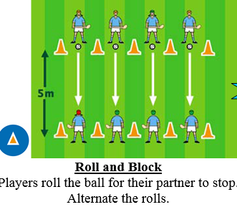

**Pitch 2.**

**Ground strike**

Start with pairs striking the tyres then proceed to striking between pairs

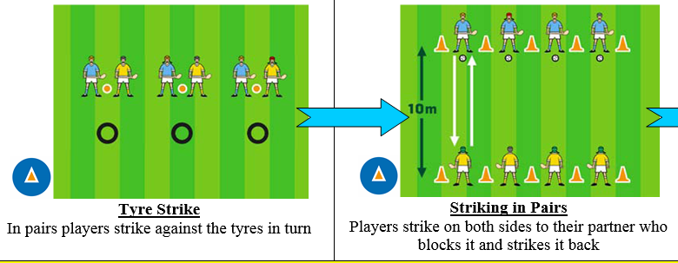

**Pitch 3.**

**Dribble**

Start with out and back and then a game with 2 teams where you have to dribble over the line to score

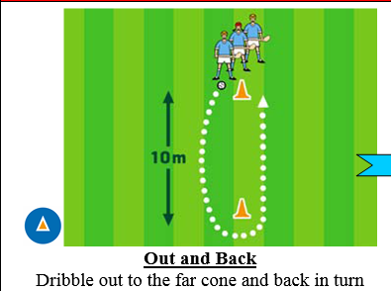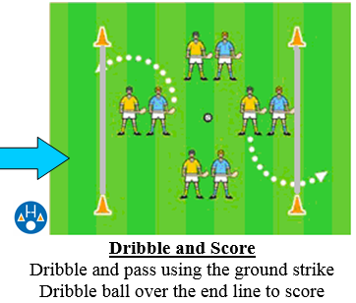

**Pitch 4. Shoulder clash**

At the outset explain how you can use your shoulder to push the other player, and how a tackle can be made in hurling

