**Football Training Session – Academy**

**WARM UP**

Check for Gum Shields. Start off with a few shuttle runs and get the players running. Throw in a few Bear Crawls, Leap Frogs, side step and backwards running.

**Pitch 1.**

**BLOCK DOWN**

Two Groups of Players – Attackers and Defenders

Attackers in turn move forward with the ball and take a shot at Goal (marked at a cone area). The defender makes the effort to Block the Attackers ball.

The Player then joins the back of the opposite queue so they all keep rotating and taking turns Attacking and Blocking.

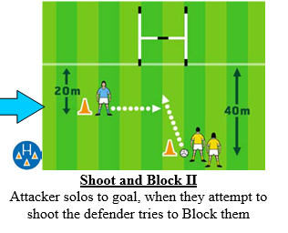

Please make sure you demonstrate the Blocking  movement and encourage the players to get down stretch their Arms out with hands cupped to block the ball.

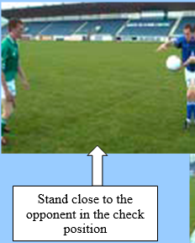   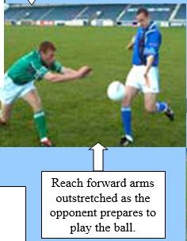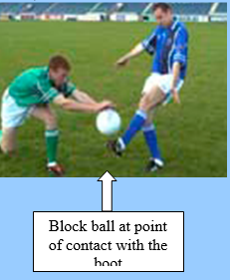

**Pitch 2.**

**BODY CATCH**

Two Groups of Players – Throwers and Catchers with 4 or 5 players on either side.

It’s up to the Thrower (or Coach depending how it goes) to throw the ball up for the Catcher to catch while he’s running forward. The Catcher then runs

straight on with the ball and Hand passes to the next Player in line while he joins the back of the queue to become a Thrower. The Players will always join

the opposite queue so they all keep rotating and taking turns Throwing and Catching. *(Put in a few High Balls and Low Balls to mix it up a bit).*

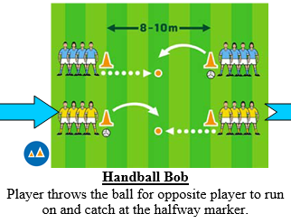

**Pitch 3.**

**NEAR HAND TACKLE**

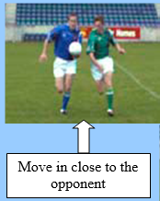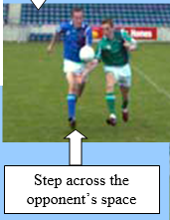 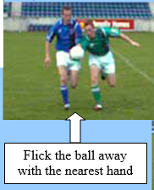 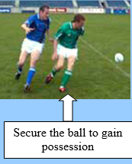

Get the Players into two lines, one player starts off carrying and bouncing the ball forward. The other player Steps across

And completes the Near Hand Tackle. Have the Players alternate the positions so everyone gets to Carry and Tackle.

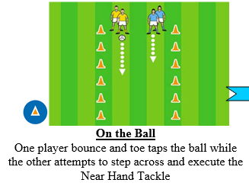

**Pitch 4.**

**KICK PASS / PUNT KICK**

Put out 4 x Cones, two players at each cone. Get one Player to start, go clockwise and get the Player to Kick Pass to the Player at the next cone.

The player Kicking the Ball must follow the ball and join the end of the queue at the next cone.

The Kicker is a follower to start off with and as the ball comes around they become a catcher also.

